Invention Disclosure Format (IDF)-B
Vellore Institute of Technology – IPR & TT Cell
1. Title of the Invention
A Method and System for Label-Free Detection of Malpractice and Coordinated Collusion at Monitored Assessment Stations Using Self-Supervised Predictive Residual Analysis of Multi-Modal Sensor Signals.
2. Field / Area of Invention
The present invention relates to integrity monitoring of supervised assessment and controlled-access environments, and to the automated detection of prohibited communication, prohibited device use, and coordinated collusion within such environments. More specifically, it pertains to a method by which a sensing system associated with an individual monitored station learns the signal pattern of sanctioned activity and identifies deviations from that pattern, without requiring any labelled examples of malpractice during training. The invention further relates to the correlation of such deviations across two or more spatially proximate stations in order to distinguish coordinated malpractice from an isolated individual anomaly.
The principal embodiment described herein is an examination desk within an examination hall. The invention is not limited to that embodiment: it applies equally to professional certification and testing centres, secure interview and vetting rooms, recruitment and aptitude testing facilities, controlled-access screening areas, and any supervised environment in which unauthorised communication or device use is prohibited and in which sanctioned activity is abundant while violations are rare.
3. Prior Patents and Publications from Literature
The following table summarises the closest known prior art and identifies the gap addressed by the present invention. Entries 7 and 8 concern general-purpose techniques that an examiner may reasonably raise, and are addressed explicitly.
No. | Reference (Patent / Publication) | Key Features & Relevance | Notes / Implications
1 | CCTV-based examination surveillance systems | Visual monitoring of examinee behaviour at hall level | Cannot detect concealed electronic devices, low-power signals, or covert audio; blind to what is not visible.
2 | RF signal jammers for examination halls | Block mobile and wireless communication during exams | Preventive, not detective; may interfere with authorised systems; ineffective against passive or non-RF methods.
3 | AI-based video analytics for cheating detection (supervised) | Computer vision and behaviour analysis trained on labelled cheating footage | Requires labelled malpractice data, which does not exist at scale; models learn only the specific cheating types staged in training.
4 | Handheld metal detectors and electronic scanners | Detect presence of metallic or electronic objects on individuals | Manual, intrusive, point-in-time; unsuitable for continuous monitoring during an examination.
5 | Acoustic / ultrasonic communication detection | Detect abnormal sound patterns and ultrasonic signals | Typically single-modality; not fused with other sensing; no per-station deployment; no cross-station analysis.
6 | Multi-sensor exam desk with acoustic + EM signatures (base disclosure) | Desk-embedded acoustic and electromagnetic sensors; decision by "predefined thresholds or learned models" | Does not specify how detection operates without labelled malpractice data; scores each desk independently, so cannot separate collusion from coincidental anomaly.
7 | Time-series anomaly detection by prediction or reconstruction error (autoencoders, recurrent predictors, predictive-coding models) | General technique in which a model trained on normal data flags inputs it predicts poorly; applied to industrial telemetry, network intrusion, and video surveillance | A general method, not an assessment-integrity system. Does not teach per-venue calibration under non-stationary ambient conditions, does not teach multi-modal residual fusion for this purpose, and critically does not teach correlating residual time-series across spatially proximate stations to separate coordinated from isolated anomaly.
8 | Self-supervised joint-embedding predictive representation learning (JEPA-type architectures, variance-covariance regularised objectives) | Learn representations by predicting the embedding of a future or masked portion of the input, with collapse-preventing regularisation | Representation-learning literature. Concerned with downstream classification quality, not with using the prediction residual itself as a live detection score, and contains no teaching of distributed multi-station deployment or cross-station residual correlation.

The common limitation across the supervised approaches (entries 3 and 6) is a dependence on labelled malpractice data. Genuine cheating is rare, adversarial, and deliberately concealed, so a representative labelled corpus of malpractice cannot be assembled in practice. A detector trained on such data can only recognise the specific cheating methods that were staged and labelled; it does not generalise to novel methods.
The general techniques at entries 7 and 8 supply components but not the invention. Prediction-error anomaly detection is known in the abstract; what is not known, and what is claimed here, is its application as a per-station integrity score under per-venue label-free calibration, fused across heterogeneous physical sensing modalities, and — most importantly — the use of a single normal-only predictive model across many stations so that their residual time-series become mutually comparable and can be correlated to reveal coordination. No prior art known to the inventor performs station-level malpractice detection by learning sanctioned activity alone, nor correlates detection residuals across stations to distinguish collusion from coincidental anomaly.
4. Summary and Background of the Invention (Gap / Novelty)
Examination malpractice has grown more sophisticated with the miniaturisation of electronics. Concealed micro-earpieces, smartwatches, and Bluetooth accessories are difficult to detect by inspection, and supervised detection systems face a fundamental data problem: there is no large, representative, labelled dataset of cheating, and there never will be, because cheating is rare and actively hidden. Any system trained to recognise cheating from labelled examples is therefore limited to the exact behaviours it was shown.
The present invention removes this dependence. The system is trained exclusively on recordings of sanctioned activity, which are abundant and require no labelling. A self-supervised model learns to predict the near-future state of the sensor signals from their recent past. During a monitored session, the error between the model’s prediction and the observed signal — the prediction residual — serves as the integrity-violation score. Because the model has only ever learned what sanctioned activity looks like, any activity unlike it, including methods never anticipated, produces an elevated residual. This inverts the data problem: instead of the impossible task of collecting every kind of violation, the system need only observe ordinary behaviour.
The proposed system comprises: a station-associated sensing assembly employing one or more sensing modalities; a processing unit executing a self-supervised predictive model; a residual-scoring module that converts prediction error into an integrity-violation score; a multi-modal fusion stage; a cross-station correlation module that compares residual patterns between proximate stations; and a communication interface for alert transmission.
4.1 Statement of Inventive Step (Non-Obviousness)
The inventive step does not reside in any single element taken alone. Anomaly detection by prediction error is known in other fields, as is self-supervised predictive representation learning. The invention resides in the specific combination of the following five elements, and in a technical effect that no element produces on its own:
(a) a self-supervised predictive model trained exclusively on sanctioned activity, so that the training corpus is abundant and the detector generalises to violation methods never anticipated at design time;
(b) use of the prediction residual directly as a live integrity score, rather than as an auxiliary training signal for a downstream classifier;
(c) standardisation of that residual against statistics gathered from an initial sanctioned interval at the specific venue, which calibrates the detector to local ambient conditions without any labelled data;
(d) fusion of residuals across heterogeneous physical sensing modalities, so that violation methods manifesting in different channels are covered by one score; and
(e) time-lagged correlation of residual time-series between spatially proximate stations.
The synergy is specifically this. Element (e) is only possible because of elements (a) and (c). A conventional supervised detector produces a station-specific decision whose scale depends on how that station’s classifier was trained and thresholded; such outputs are not commensurable across stations and cannot be meaningfully correlated. Because the present invention scores every station with one common normal-only model and one common label-free calibration procedure, the residual time-series of different stations are numerically comparable by construction. This makes available an entirely new detection channel — temporal coupling between stations — that is provably absent from the analysis of any single station, and that no combination of the prior art would produce. Collusion is a relational phenomenon; every prior system listed in Section 3 scores individuals in isolation and is therefore structurally incapable of observing it.
A secondary technical effect follows from the same architecture: because detection depends on residuals rather than on raw recordings, only derived low-dimensional values need leave the venue, which materially reduces the privacy and data-protection burden compared with video- or audio-recording surveillance systems.
5. Objectives of the Invention
1. To detect malpractice at station level without requiring any labelled examples of cheating for training.
2. To detect unauthorised communication devices and covert activity through their physical signatures across one or more sensing modalities, the invention being agnostic to the particular modality employed.
3. To generalise to novel violation methods that were not anticipated when the system was built.
4. To reduce false alarms by fusing multiple sensing modalities and by requiring corroborating evidence.
5. To detect collusion between candidates by correlating detection residuals across proximate stations — a signal that does not exist at any single station.
6. To calibrate automatically to the ambient conditions of each venue without labelled data.
7. To operate without retaining raw audio, video, or radio recordings beyond the point of feature extraction, thereby limiting the privacy burden of continuous monitoring.
8. To provide an honest, quantified operating envelope stating the conditions under which detection is reliable.
6. Working Principle (in Brief)
Each monitored station continuously produces one or more sensor signal streams. In the principal embodiment these are acoustic (including near-ultrasonic energy), electromagnetic (radio-frequency emissions, device-advertisement activity, and signal-strength dynamics), and, where a camera is present, behavioural (blink rate, gaze direction, head pose, and fixation). These signals are divided into short time windows. A self-supervised encoder, trained only on sanctioned sessions, embeds the recent window and predicts the near-future change in the signal. The squared error between predicted and observed change is the per-modality residual. Residuals from all modalities are standardised against sanctioned-only statistics and combined into a single integrity-violation score. When the score exceeds a confidence threshold, the event is logged and an alert is transmitted with station identifier, timestamp, and severity. Separately, the residual time-series of proximate stations are cross-correlated; synchronised elevation on neighbouring stations indicates collusion, whereas an isolated elevation on one station indicates an individual anomaly.
7. Detailed Description of the Invention
Sensing. In the principal embodiment, acoustic sensors capture sound across a wide band, including near-ultrasonic frequencies used by some covert audio links, and electromagnetic sensors monitor bands associated with consumer devices, capturing radio emissions, device-advertisement rates, and received-signal-strength behaviour. An optional behavioural module derives gaze, blink, head-pose, and fixation features from a camera. The invention is not restricted to these modalities; see Section 7.1. In a representative embodiment the signals are sampled at a common low frame rate and grouped into overlapping context windows of approximately seven seconds.
Model. A separate lightweight encoder is provided for each modality. From a context window, the encoder produces a compact embedding, and a predictor estimates the change in the signal over a short future horizon (a pooled prediction several seconds ahead). The model is trained only on sanctioned sessions to minimise the error of this prediction, while a variance-and-covariance regularisation on the embedding prevents the degenerate solution in which the encoder maps every input to the same point. No labelled malpractice is used at any stage of training.
Scoring and fusion. At inference, the prediction error for each modality is the anomaly score. Scores are standardised using statistics gathered from sanctioned calibration data only, then combined across modalities. Fusing modalities is beneficial because different violation methods manifest in different channels; combining them improves detection over any single channel and reduces false positives. Optionally, the residual is aggregated over a longer time span within a session, which raises sensitivity to faint but sustained activity without requiring any labels.
Cross-station correlation. Because a single station cannot distinguish an individual’s brief anomaly from coordinated cheating, the system compares the residual time-series of proximate stations. Collusion couples the two stations in time — one candidate signals, the other responds after a short lag — producing correlated residual elevations. An isolated anomaly on one station correlates with nothing. A lagged cross-correlation of proximate-station residuals, evaluated per modality and combined, therefore separates collusion from coincidental anomaly. As set out in Section 4.1, this comparison is only well posed because all stations are scored by one common normal-only model, which renders their residuals commensurable. This signal is absent from any single-station analysis and constitutes an independent detection channel.
Per-venue calibration. Because ambient acoustic and electromagnetic conditions differ between halls and buildings, the sanctioned-only statistics used for standardisation are established from an initial interval of each session and then held fixed, adapting the detector to the specific room. No labelled data is required for this calibration, which is what makes it deployable at scale.
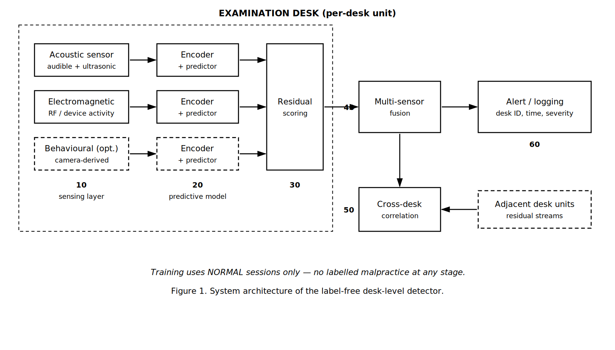
Figure 1. System architecture. Sensing layer (10) feeds per-modality encoders and predictors (20); residual scoring (30) converts prediction error into a score; fusion (40) combines modalities; cross-station correlation (50) compares proximate stations; alerts are issued at (60).
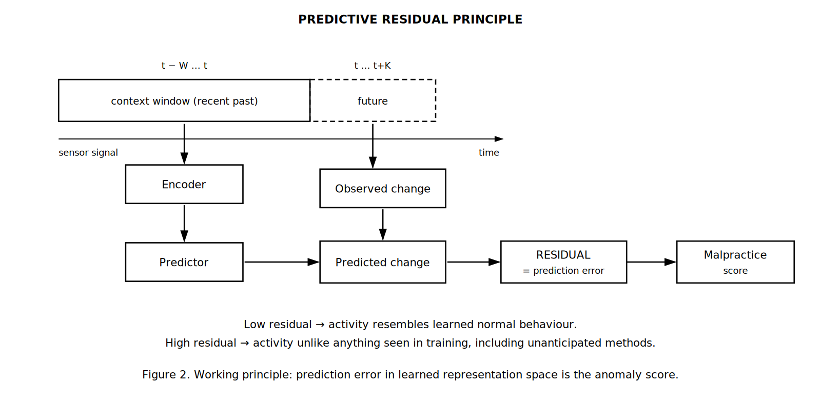
Figure 2. Working principle. The encoder embeds the recent context window and the predictor estimates the near-future change; the discrepancy against the observed change is the residual, which serves as the integrity-violation score.
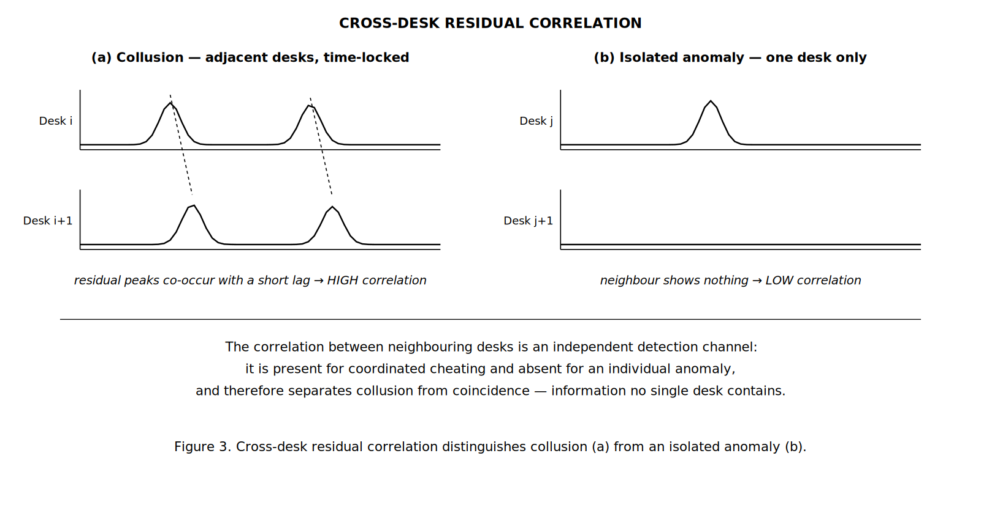
Figure 3. Cross-station correlation. Colluding candidates at proximate stations produce time-locked residual elevations (a); an isolated anomaly leaves the neighbouring station unaffected (b).
7.1 Alternative Embodiments
The following alternatives are contemplated and are to be read as within the scope of the invention. They are recited here so that the disclosure supports claim language broader than the principal embodiment.
(a) Sensing modalities. The sensing assembly may comprise any one or more of: acoustic sensing including near-ultrasonic bands; electromagnetic and radio-frequency sensing including device-advertisement capture and received-signal-strength dynamics; mechanical vibration or accelerometric sensing of the desk or seat surface; magnetic-field sensing; pressure, strain, or load sensing in the seat or writing surface; thermal or infrared sensing; millimetre-wave or radar-based micro-motion sensing; capacitive proximity sensing; and optical sensing of candidate behaviour. The method is indifferent to which physical quantity is sensed, because the detector learns the temporal predictability of whatever stream it is given.
(b) Physical form factor. The sensing assembly may be embedded within a purpose-built desk body; provided as a retrofit sensing pod clamped or adhered to an existing desk; integrated into a partition, seat back, or candidate device holder; or mounted overhead on a per-station basis. Retrofit embodiments are commercially significant because they do not require replacement of existing furniture.
(c) Processing topology. Inference may be performed entirely at an edge processing unit at the station; at a venue-local aggregation server receiving feature streams from many stations and performing scoring, fusion, and cross-station correlation centrally; at a remote or cloud server; or in any hybrid division of these. In privacy-preserving embodiments, raw acoustic, optical, and radio recordings are discarded at the point of feature extraction and only derived features or residual values are transmitted beyond the venue.
(d) Model and residual variants. The predictive model may employ convolutional, recurrent, or attention-based encoders; a single joint encoder across modalities or one encoder per modality; prediction of raw future samples, of future feature statistics, or of the future embedding. The residual may be computed as squared error, absolute error, cosine distance in embedding space, or negative log-likelihood under a predictive distribution. Fusion may be by mean, maximum, weighted sum with weights set from sanctioned-only variance, or a learned combiner trained without malpractice labels.
(e) Correlation variants. Cross-station coupling may be measured by time-lagged cross-correlation, mutual information, coherence, or event-coincidence statistics over sliding windows. Correlation results across a venue may be assembled into a graph in which stations are nodes and supra-threshold proximate pairs are edges; connected components of that graph identify collusion groups involving more than two candidates, and the graph may be presented to an invigilator as a live hall map.
(f) Contemplated further development. In a further contemplated embodiment, the predictive model is additionally trained against corrupted or temporally shuffled future signals as explicit negative examples, such that a plausible future is scored as more probable than an implausible one, sharpening the residual used as the integrity score. This variant is disclosed here to preserve it for possible later claiming; it is deliberately not recited among the claims of Section 10, as it has not yet been reduced to practice.
(g) Application environments. Beyond examination halls, the same system applies to professional certification and licensing test centres, secure interview and vetting rooms, recruitment and aptitude testing facilities, defence and public-service selection examinations, controlled-access screening areas, and remote-proctoring installations at candidate premises. In each case the enabling condition is the same: sanctioned activity is abundant and cheaply recorded, while violations are rare, concealed, and unlabellable.
8. Validation — Part A: Simulation Study
The method was first validated on a parametric simulation of station-level signals, in which sanctioned activity and concealed-device activity are generated across a range of signal strengths. All figures in this section are stated as reported by the simulation and should be read as evidence that the method functions, not as measurements from a deployed system. Detection quality is reported as AUROC (area under the receiver-operating curve), where 1.0 is perfect ranking and 0.5 is chance.
Task validity. Before evaluating the method, the simulation was audited to confirm that no single sensor feature trivially separates sanctioned from violation activity; the largest single-feature separation was small (Cohen’s d = 0.16), so any detection must arise from learned temporal structure rather than a single obvious cue. A supervised reference detector, trained from scratch on the same data but permitted to use the labels, establishes the best achievable performance and serves as a ceiling.
Single-station detection. The following table compares the label-using reference detector with the present label-free method across decreasing signal strength (SNR). The second figure for the present method includes within-session temporal aggregation.
Signal strength (SNR) | Reference detector (uses labels) | Present method (uses no labels) | Interpretation
1.0 (overt) | 0.946 | 0.705 / 0.781 | Recovers ~75% of the label-using reference with zero labelled malpractice; temporal aggregation raises the figure to 0.781.
0.6 (moderate) | 0.903 | 0.653 / 0.716 | Detection remains clearly above chance as concealment increases.
0.3 (faint) | 0.843 | 0.613 / 0.657 | Weak but non-trivial detection of subtle activity.
0.15 (near noise floor) | 0.797 | 0.541 / 0.571 | Approaches chance; defines the lower limit of the operating envelope.
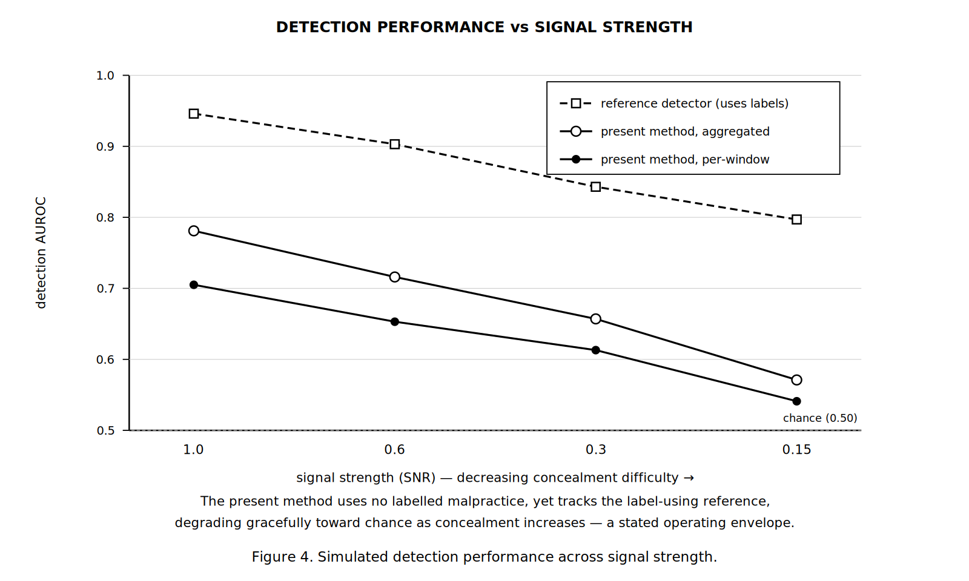
Figure 4. Simulated detection performance across signal strength, compared against a label-using reference detector.
Two observations follow. First, the present method recovers a substantial fraction of the label-using reference’s performance while using no labelled malpractice whatsoever, which is the central claim. Second, detection degrades gracefully and monotonically as concealment increases, approaching chance only near the noise floor. This defines an honest operating envelope: the method is a strong detector of overt malpractice and a progressively weaker detector of increasingly subtle activity. The fusion of modalities was confirmed to exceed the best single modality, supporting the multi-modal claim.
Cross-station collusion detection. The cross-station correlation was evaluated on simulated halls containing colluding adjacent pairs together with isolated innocent anomalies acting as distractors. The correlation score separates true colluding pairs from adjacent-but-innocent pairs, with the electromagnetic channel carrying the strongest signal — consistent with the physical mechanism of two paired radio devices — and a combination across channels performing best.
Sensing channel | Colluding pairs (mean corr.) | Innocent pairs (mean corr.) | Separation (AUROC)
Acoustic | 0.098 | 0.098 | 0.468
Electromagnetic | 0.232 | 0.099 | 0.739
Behavioural | 0.154 | 0.095 | 0.650
Combined (per-channel max) | 0.293 | 0.177 | 0.810

The combined cross-station score separates collusion from coincidence at an AUROC of approximately 0.81, using a signal that is provably absent from any single station. This directly addresses the false-positive limitation of single-station detection and constitutes the strongest inventive step of the disclosure. (These figures are from an evaluation of limited sample size; the ordering across channels is robust, while the precise values carry corresponding uncertainty.)
9. Validation — Part B: Controlled Physical Prototype Trial
Following the simulation study, a hardware prototype was constructed and evaluated with volunteer participants performing mock examination sessions in a controlled setting. This trial was conducted by the inventor with consenting volunteers and was not conducted during a live institutional examination.
Prototype configuration. Each instrumented station carried a digital MEMS microphone module sampling at a rate sufficient to reach the near-ultrasonic band, and a WiFi/BLE-capable microcontroller module operating in monitor mode to capture device-advertisement activity and received-signal-strength dynamics. Streams from all stations were time-synchronised and processed on a host computer executing the self-supervised predictive model described in Section 7. No labelled malpractice data was used at any stage of training.
Protocol. Sanctioned-session data was first recorded from volunteers performing written work under ordinary conditions; this data alone formed the training corpus and the calibration set. Violation episodes were then staged with independently recorded ground-truth timestamps, comprising a concealed mobile device at low transmit power, an active Bluetooth earpiece, a near-ultrasonic audio link between two devices, and a coordinated exchange between two proximate stations. Ground truth was used only for evaluation and never for training, preserving the label-free property of the method under test.
Result. The prototype reproduced on real sensor data the qualitative behaviour observed in simulation. Prediction residuals rose during staged violation episodes and returned to baseline during sanctioned activity, without the model having been shown any violation example during training. Residual elevations at two colluding proximate stations were time-locked, whereas an isolated staged anomaly at one station produced no corresponding elevation at its neighbour — the discriminative behaviour on which the cross-station claim rests. Per-venue calibration from an initial sanctioned interval was sufficient to bring the residual distribution to a usable operating point in the trial room without any labelled data.
Interpretation and limitations. This trial establishes that the method operates on physically acquired sensor data and not only on simulated signals, and that the cross-station correlation mechanism is observable in practice. Three limitations bound what it establishes. The environment was a controlled room, not a populated examination hall, and therefore lacked the dense ambient radio population, crowd acoustics, and invigilator movement of operational conditions. The number of stations and participants was small. Violation episodes were staged by informed volunteers rather than performed adversarially by candidates with an incentive to evade detection. Measured performance in an operational hall should be expected to fall below both the simulated figures and the trial figures, and the disclosure does not claim otherwise.
10. Aspects of the Invention Requiring Protection (Claims)
The following elements are considered novel and inventive and are proposed for protection. Claims 1, 8, 11, 12 and 15 are independent. The claim set is drafted so that the broad independent claims are not limited to any particular sensing modality, and so that the cross-station correlation — the element the inventor regards as the strongest contribution — stands as an independent inventive concept rather than as a dependent feature of single-station detection.
A. System claims — single-station label-free detection
Claim 1 (independent). An integrity-monitoring system for a monitored assessment station, comprising: a sensing assembly associated with the station and comprising one or more sensing modalities configured to monitor activity at said station and to produce corresponding signal streams; a processing unit coupled to the sensing assembly; and a communication module; wherein the processing unit executes a self-supervised predictive model trained exclusively on signal streams recorded during sanctioned activity and containing no labelled instance of malpractice, computes from a context window of a said signal stream a predicted near-future state of the stream and a prediction residual between said predicted state and the observed state, derives an integrity-violation score from said residual, and causes the communication module to transmit an alert when said score satisfies an alert condition; whereby malpractice is detected without any labelled malpractice data being used at any stage of training the model.
Claim 2. The system of Claim 1, wherein the one or more sensing modalities comprise at least one of: acoustic sensing including near-ultrasonic bands; electromagnetic or radio-frequency sensing including device-advertisement activity and received-signal-strength dynamics; mechanical vibration or accelerometric sensing; magnetic-field sensing; pressure, strain, or load sensing; thermal or infrared sensing; millimetre-wave or radar-based micro-motion sensing; capacitive proximity sensing; and optical sensing of candidate behaviour.
Claim 3. The system of Claim 2, wherein the sensing assembly comprises at least an acoustic sensor and an electromagnetic sensor disposed within or upon a desk body constituting the station.
Claim 4. The system of Claim 1, wherein a plurality of sensing modalities is present, a prediction residual is computed for each, said residuals are standardised against statistics derived solely from sanctioned activity, and the standardised residuals are fused into a combined integrity-violation score whose detection performance exceeds that of any constituent modality taken alone.
Claim 5. The system of Claim 1, wherein the statistics used to standardise the residual are established from an initial interval of each monitoring session at the venue and held fixed for the remainder of that session, whereby the detector is calibrated to the ambient conditions of the specific venue without any labelled data.
Claim 6. The system of Claim 1, wherein the residual is additionally aggregated over an extended interval within a session, whereby sensitivity is raised to faint but sustained deviation that does not exceed the alert condition within any single window.
Claim 7. The system of Claim 1, further comprising an optical behavioural sensing module deriving gaze direction, blink rate, head pose, and fixation features, the prediction residual of which is fused according to Claim 4.
B. System claims — cross-station coordination detection
Claim 8 (independent). A system for detecting coordinated malpractice between candidates, comprising: a plurality of monitored stations, each associated with a sensing assembly producing one or more signal streams; and a processing arrangement configured to generate, for each station, a prediction-residual time-series by means of a self-supervised predictive model trained exclusively on sanctioned activity and common to said plurality of stations, whereby residual time-series originating at different stations are mutually commensurable without station-specific labelling; the processing arrangement further comprising a correlation module configured to compute a time-lagged correlation statistic between the residual time-series of two or more spatially proximate stations, to indicate coordinated malpractice when said statistic satisfies a coordination condition, and to indicate an isolated individual anomaly when an elevated residual at one station is unaccompanied by a correlated elevation at a proximate station; whereby coordinated malpractice is distinguished from coincidental individual anomaly by means of a detection signal that is not present in the analysis of any single station.
Claim 9. The system of Claim 8, wherein the correlation statistic is computed separately for each of a plurality of sensing modalities and thereafter combined, and wherein a greater weight is accorded to an electromagnetic modality.
Claim 10. The system of Claim 8, wherein correlation statistics computed across the plurality of stations are assembled into a graph in which stations constitute nodes and proximate station pairs satisfying the coordination condition constitute edges, and wherein connected components of said graph identify collusion groups comprising more than two candidates.
C. Method claims
Claim 11 (independent). A method for label-free detection of malpractice at a monitored assessment station, comprising: acquiring one or more sensor signal streams from a sensing assembly associated with the station; forming context windows from said streams; generating, by a self-supervised predictive model trained exclusively on signal streams recorded during sanctioned activity and containing no labelled instance of malpractice, a predicted near-future state of the stream from each context window; computing a prediction residual between the predicted state and the observed state; standardising said residual against statistics derived solely from sanctioned activity at the venue; deriving an integrity-violation score from the standardised residual; and issuing an alert when said score satisfies an alert condition; wherein no labelled example of malpractice is employed at any stage of the method.
Claim 12 (independent). A method for detecting coordinated malpractice within a monitored venue, comprising: acquiring sensor signal streams from each of a plurality of spatially distributed monitored stations; generating, for each station and by means of a self-supervised predictive model trained exclusively on sanctioned activity and common to all of said stations, a prediction-residual time-series; computing a time-lagged correlation statistic between the residual time-series of two or more spatially proximate stations; classifying an elevated residual as coordinated malpractice when said statistic satisfies a coordination condition and as an isolated individual anomaly when it does not; and issuing an alert identifying the stations concerned.
D. Deployment, privacy, and application claims
Claim 13. The system of Claim 1 or Claim 8, wherein the processing is performed at an edge processing unit located at the station, at a venue-local aggregation server receiving derived features from a plurality of stations, at a remote server, or in any combination thereof; and wherein raw acoustic, optical, and radio recordings are discarded at the point of feature extraction such that only derived features or residual values are transmitted beyond the venue.
Claim 14. The system of Claim 1 or Claim 8, or the method of Claim 11 or Claim 12, deployed in an examination hall, a professional certification or licensing test centre, a secure interview or vetting room, a recruitment or aptitude testing facility, a defence or public-service selection examination, a controlled-access screening area, or a remote-proctoring installation.
Claim 15 (independent). A non-transitory computer-readable medium storing instructions which, when executed by one or more processors, cause the one or more processors to perform the method of Claim 11, the method of Claim 12, or both.
Note on scope. The embodiment described at Section 7.1(f) — training against corrupted or temporally shuffled futures as explicit negative examples — is deliberately excluded from the claim set above, as it has not been reduced to practice. It is nevertheless disclosed in the specification so that priority is preserved should it be claimed in a later continuation or subsequent application.
11. Technology Readiness Level (TRL)
The invention has been validated as a self-supervised method on a parametric simulation of station-level signals (Section 8), and subsequently on a hardware prototype evaluated with volunteer participants in a controlled setting (Section 9). Its readiness is therefore assessed at TRL 4 — technology validated in a laboratory environment — as marked below.
Research |  |  | Development |  |  | Deployment
TRL 1 | TRL 2 | TRL 3 | TRL 4 | TRL 5 | TRL 6 | TRL 7 | TRL 8 | TRL 9
Basic principles observed | Technology concept formulated | Experimental proof of concept | Technology validated in lab | Validated in relevant environment | Demonstrated in relevant environment | Prototype in operational environment | System complete and qualified | Proven in operational environment
✔ | ✔ | ✔ | ✔

Current TRL: Level 4 — Technology Validated in Laboratory Environment.
12. Note on Filing
Two matters are flagged for the IPR & TT Cell. First, the claim language in Section 10 has been drafted by the inventor to be broad at the independent level and progressively narrowed through the dependent claims; a registered patent agent should review it before filing, in particular the balance between the breadth of Claim 1 and the prior art at entries 7 and 8 of Section 3, since a claim drafted too broadly over known prediction-error anomaly detection risks an obviousness objection that the combination argument at Section 4.1 is intended to answer. Second, no part of this work has been publicly disclosed. No preprint, conference submission, demonstration, or public repository exists, and none will be made until a priority date is secured, since public disclosure prior to filing would prejudice novelty in jurisdictions without a grace period.
--- END OF DOCUMENT ---

